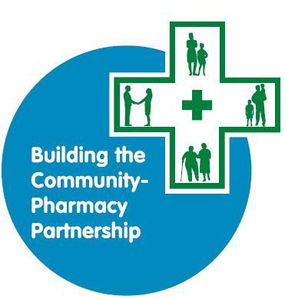
Applications must be submitted via email to: bcpp@cdhn.org
BCPP Level 2 Guidance Notes
TO ACCOMPANY THE BCPP LEVEL 2 APPLICATION FORM

CONTENTS

- Introduction to Community Development and Health Network (CDHN)

- Building the Community-Pharmacy Partnership Programme (BCPP)

- BCPP assessment criteria

- Question by question guide

- Information about successful applications

- Keep to the word count for each answer.
- Applications must be typed.
- You must email your application form to bcpp@cdhn.org by the closing date. An electronic signature is accepted at this stage.
- On submitting the application, you must have commitment from both the community and pharmacy partners to deliver the project.
- Please keep a copy of your submitted application for your records.

Introduction to Community Development and Health Network (CDHN)

Our Vision is for an end to health inequalities
Our Mission is building a fairer and more equal society, and improving people’s lives, health and well-being through community development which releases individual and community capacity and influences change.
Our Statement of Values:
- Leading with passion
In all our work we will lead with passion using our expertise and belief in what we are doing to inspire others.
- Tenacity and flexibility
We will be tenacious, focused and flexible to ensure an end to health inequalities.
- Integrity and respect
Through our words and actions, we will work with integrity and respect.
- Equality and inclusivity
We will recognise and promote equality and inclusivity to ensure we achieve social justice for all.
- Valuing others
We will value individuals, teams, partners and communities recognising this as a key strength to achieving our vision.

To avail of BCPP funding, the community and pharmacy partner must agree to
- CDHN Statement of values and;
- accept free membership of CDHN to receive the CDHN ezine with up to date information on funding, training and events

Building the Community-Pharmacy Partnership (BCPP)

The Building the Community-Pharmacy Partnership (BCPP) Programme is led by CDHN and funded by the Health and Social Care Board (HSCB), with strategic direction provided by a multi-agency Steering Group.
BCPP Aim: To bring pharmacy and community together to reduce health inequalities using an asset-based community development approach
BCPP Strategic outcomes | BCPP Project outcomes
1. Project participants are enabled and supported to achieve their full health and wellbeing potential | 1.1 | Participants' health literacy is improved
 | 1.2 | Participants have improved understanding of the social factors (e.g. money worries, housing, stress) that can influence health (social determinants)
 | 1.3 | Participants are more confident to self-manage their health and take action on factors which influence health
 | 1.4 | Participants have improved knowledge of services and support for health and social issues
 | 1.5 | Participants' health and wellbeing is improved
2. Pharmacy is enabled and supported to fulfil their role as advocates for public health within communities | 2.1 | Pharmacists are more aware of health issues in the participants' community
 | 2.2 | Pharmacists have better understanding of the context and conditions of people’s lives and factors that influence health (social determinants)
 | 2.3 | Pharmacists have improved health literacy understanding and skills
 | 2.4 | Pharmacists have improved knowledge of services and support for health and social issues and are better able to signpost patients
 | 2.5 | Pharmacy services are better utilised
3. Community partners are enabled and supported to recognise and address health inequalities in their community | 3.1 | Community partners are more aware of health issues in the participants’ community
 | 3.2 | Community partners have better understanding of the context and conditions of people’s lives and factors that influence health (social determinants)
 | 3.3 | Community partners have improved health literacy understanding and skills
 | 3.4 | Community partners have improved knowledge of services and support for health and social issues and are more able to signpost/refer people in their community
4. Social capital is increased to build connected and engaged communities | 4.1 | Participants have an improved sense of connectedness and belonging
 | 4.2 | Participants develop new skills, knowledge and experience in their community
 | 4.3 | More equal relationships are developed between the participants, community partner and pharmacy

What is BCPP?
BCPP supports communities and community pharmacists to work in partnership to address locally defined needs so that people make connections, listen to and understand each other better and work together to address the social determinants of health and health inequalities.
What approach is used in BCPP projects?
The programme uses an asset-based community development approach; bringing people and communities together to achieve positive change using their own knowledge, skills and lived experience around the issues they encounter in their lives. We recognise that health is impacted by a wide range of factors and the BCPP programme aims to address health inequalities by championing action across these social determinants. Co-production is key and the most successful projects are the ones where the power balance shifts and the pharmacist and community see each other’s strengths and assets. This breaks down the patient/professional barrier and gives the pharmacist an opportunity to learn about the group and hear their stories.
Why pharmacy?
The role that community pharmacies play in delivering primary care and in educating and engaging with local communities is continually developing in both the health care and community and voluntary sectors. They have a unique position, within their localities, of being the ‘open door’ to the Health Service. The policy direction for Community Pharmacy is clearly that it will play a greater role in contributing to better health and well-being in the community. We believe that the local pharmacy is an important community resource where advice and support can be accessed on health and general wellbeing, as well as being somewhere that people can be signposted to other services. The community pharmacy is increasingly recognised and used in this way. The pharmacist, their staff members and premises are easily accessible to all, including those who are most vulnerable and find it more difficult to navigate other areas of the health care system.
BCPP projects provide a fantastic opportunity to explore the potential of community pharmacy in this role; to begin to build relationships between pharmacy and community partners and to see how we can engage creatively with those most vulnerable to poor health (the poor, the elderly, those with young children and other marginalised groups such as those with disabilities, mental health problems and their carers). It also allows the opportunity to engage and learn from other community and voluntary sector organisations.
What type of projects are funded by BCPP?
BCPP projects are very diverse; they engage with many different communities e.g. women’s groups, people who are homeless, victims of violence etc in different areas (rural and urban) around different issues e.g. poverty, bereavement, social isolation, but the model of working does not change.
Who do BCPP projects work with?
In each project the community and pharmacy partner will engage with a small group of 12-15 individuals. We find this size is perfect for group work as in a small group, participants feel safe to engage and discuss what are often very personal issues about themselves and their families. Group work is core to the success of the programme. When people meet and engage with others in similar circumstances as themselves, it reduces feelings of self-blame and hopelessness. They realise they are not alone or ‘bad’ and this gives them the support to make small changes and the opportunity to address bigger issues together. A key element of BCPP is that the community partner and the pharmacist understand the context and conditions of people’s lives. This enables them to improve their health literacy and offer support that is relevant and timely. The partners will learn from the participants about health issues in their community and together they will identify individual and local assets that can tackle these.
Building trust and developing relationships is a core part of every BCPP project. As the sessions take place in a community and with the community partner, the Pharmacist can build on existing relationships.

What is the timeline for applications and funding?

The BCPP funding programme is ongoing, this means that applications can be made at any time and the application process is always open. There will be two closing dates for Level 2 each year, these will be advertised on the CDHN website.
After the closing date applications are internally assessed and prepared for external assessment by the BCPP steering group. The Steering Group meet approximately 8 weeks after the closing date. The table below shows an example timeline for a February closing date.
BCPP Level 2 Application and approximate funding timeline
 | Closing date | Assessment | Notification  /Contracts | Funding distributed  80% 20%
February Round | February | April | May | June | On completion

What is the difference between Level 1 and Level 2 BCPP projects?

Level 1 projects are BCPP taster projects, they give partners the opportunity to get a flavour of a BCPP project without committing to a full project (Level 2). In Level 1 projects, partners are able to explore how they work together, the management of the project, organising the sessions, working with the group and the evaluation, monitoring and reporting requirements. It also allows the partners to work with people in their community to identify the need for a Level 2 project, the topics or issues they would like to explore further and whether there is an interest from people in the community to commit to a full BCPP project.
What is the commitment for pharmacy to BCPP projects?
- Level 1: There is a set pharmacist commitment for Level 1 projects that cannot be changed.
- Level 2: There is a pharmacist commitment guide for Level 2. We would like all projects to follow this guide, however, we recognise that this may not always be suitable. If a project wishes to deviate from this commitment, the reasons must be stipulated clearly in the BCPP application.

Can organisations who have previously received Level 2 projects apply for level 1 funding?
Normally no, however, you will be eligible to apply again if you are working with
- a different partner for the first time, i.e. a new pharmacist or community partner
- a group with very different issues/needs to the previous Level 1
- It has been a long time since previous projects and/or there have been staff changes.
In such instances you will need to demonstrate clearly on the application why you feel there is a need for another Level 1 project.
Can you apply for Level 2 funding without having a Level 1 project?
Yes, some organisations have the knowledge, understanding and capacity to deliver a Level 2 without first delivering a Level 1.
Do you still fund Level 3 projects?
No, we no longer fund Level 3 projects.
What are the key differences between a Level 1 and Level 2 Project?
The key differences between Level 1 and Level 2 projects are summarised in the following table:

 | Level 1: BCPP taster | Level 2: BCPP full project
No of groups | 1 | 1 or 2
No of participants in each group | 10 to 15 (max) | 10 to 15 (max)
Maximum grant | £2,500 | £12,000
Project length | Max 6 months | Max 12 months
Reporting requirements | - One final report | - One mid-way report  - One final report
Evaluation requirements | - Community partner questionnaire  - Pharmacy partner questionnaire | - Community partner questionnaire  - Pharmacy partner questionnaire  - Participant START questionnaire  - Participant END questionnaire
Pharmacy commitment | Level 1: BCPP taster (Set pharmacist commitment) | Level 2: BCPP full project (Pharmacist commitment guide)
Pharmacist led sessions | 5 | 10
Pharmacist co-delivered/attended sessions | ½ day =  - One ½ day session with a community/voluntary organisation | 4 (8 x ½ day sessions) =  - 4 community/voluntary sector  - 1 celebration dinner/event  - 3 other
Pharmacist mandatory training | n/a | 1 day
Pharmacist planning and evaluation days | ½ day | 2 days
Total pharmacy commitment | 6 days | 17 days

Assessment Criteria

Who can apply?
BCPP funding is open to constituted community/voluntary organisations and community pharmacies based in Northern Ireland. Projects must be a partnership between a community/voluntary organisation and a community pharmacy. Either can be the lead applicant but both partners must be named in the application form.
A constituted community/voluntary organisation is a group which may be run on a voluntary basis and is set up as an organisation with a management committee, constitution and its own bank account. A copy of the constitution will be required with the application.
The community pharmacy must hold a current contract with HSCB. Qualified pharmacists not associated/affiliated to a pharmacy holding a HSCB contract are not eligible to apply.
Who is not eligible?
- Private companies and statutory organisations.
- Third party applicants e.g. an organisation applying as lead partner to deliver the project in a different community organisation. The community organisation itself or the pharmacy must be the lead partner.
What we fund?
- Level 2 Funding is for a grant of up to £12,000 for a project that can last up to one year.
- A community/voluntary organisation and a community pharmacy to work in partnership to deliver a project to either one, two and in some circumstances three groups of people. Each group should have 12-15 people who participate in all sessions.
- Projects which seek to address the social determinants of health using a community development approach.

What do we not fund?
- Health fairs
- Projects that work with a different group of people every session
- Projects with more than 15 people in a group
- Projects seeking to enhance sports performance or focus only on lifestyle issues
- Capital equipment
What is the funding criteria?
- A concise aim and summary of the proposed project.
- An identified community need.
- Clear partnership working between the pharmacy, the community and the participants (co-production).
- At least four external community/voluntary organisations co-delivering sessions.
- A clear plan for recruiting participants and keeping them engaged.
- A clear vision of the difference the project will make, which is in line with BCPP outcomes.
- A clear activity plan, including, the number of people in each group, how often they will meet and an idea of topics you hope to cover.
- Realistic costings that relate to your overall application and activity.
- Overall value for money regarding what the project aims to achieve.

Refusal of Grant
Grants may be refused for the following reasons:
- The proposed project does not meet with BCPP funding criteria.
- The application form is incomplete.
- An old BCPP application form has been submitted. Please ensure you have downloaded the correct application for the funding round.
- The application form is a copy of a previous form you submitted to CDHN
- The application does not meet the minimum scoring.
- Previous BCPP project outcomes and/or reporting requirements were not satisfactory.
- The lead partner has an open BCPP project.
- The application has not adhered to the word count.
- Sometimes demands on BCPP grants outstrip the funds available and this means that some good applications, while meeting the criteria may not be successful. In this case, funding will be awarded first to those with the highest overall score.

Question by Question Guide

PART 1: Partner Information

 | Provide details of the Community Partner (community/voluntary organisation) and Pharmacy Partner applying. Tell us who will lead the project – either the Community or Pharmacy Partner. The lead partner will be the main contact person who can give more information on the application. If successful, the contract will be with the lead partner and they will be responsible for managing the budget and returning all financial documentation, monitoring information and evaluation forms to CDHN.
This question is to ensure the community/voluntary organisation or community pharmacy applying are eligible to receive a grant, otherwise, the application will not pass the basic criteria assessment.
- If you are a group, you must be constituted so please attach a copy of your constitution with your application.
- If you are a pharmacy you must have the approval of the Pharmacy Contract Holder.
1.3 | If you are a community/voluntary organisation, please provide the Assessment Panel with a brief history of your organisation and of the work you are currently carrying out. This information will give the Panel an insight into the work of your organisation and how this may contribute to and complement the work of your BCPP project. (Maximum 100 words)
1.4a  1.4b | If the lead partner has previously received BCPP funding, tell us how many times they have been funded at each Level.  You must take a break from BCPP funding for one year if you:  - Work with the same participants through 3 projects  - Work with different participant groups on 6 projects
1.4c | It is important that you reflect on previous projects; review the outcomes from your project/s and the feedback from partners and participants. You will need to demonstrate how you will apply the learning in the design and delivery of the new project.
1.5 | Tell us approximately how many people are employed in the community partner organisation.

.

PART 2: Assessment

2.1a | Tell us which Health and Social Care Trust area/s your project will cover.
2.1b | Tell us which Council area/s your project will cover.
2.1c | Is the project in an urban or Rural area or across both areas.
 | Please write the Super Output Area (SOA) and the Multiple Deprivation Measure (MDM) rank for your BCPP group(s). You need to provide the SOAs and MDMs that your participants live in or come from, not just where your premises are based. We understand that your project may cover a wide geographical area, in this case, please provide us with a maximum of 4 SOA’s.
To find your SOA and MDM rank:
Visit: www.nisra.gov.uk/ninis

Step A: Select ‘Area Profile’ on the tabs along the top
Step B: In ‘Search for area’: Enter the postcode(s) of the area(s) the group will be from and Under ‘Geography’, select SOA. Click on the arrow highlighted to continue to the next step.
Step C: From the results click on your ‘Geography Result’.

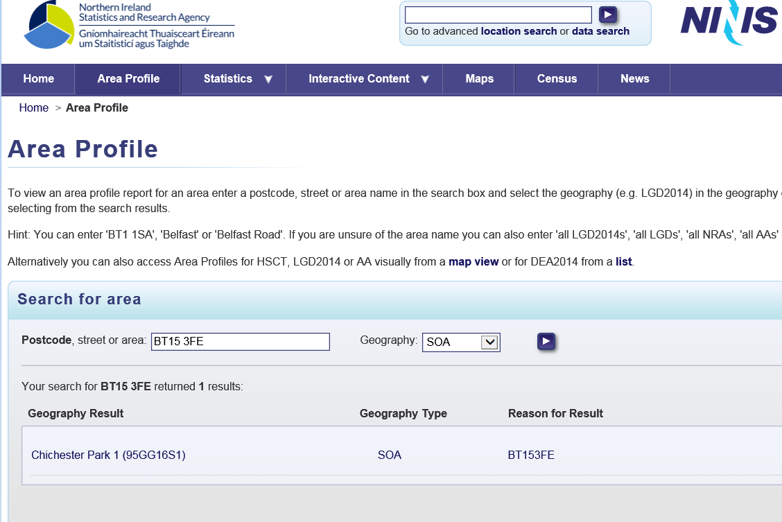

Step D: The next screen opens with the ‘Population 2016’ tab as default. Please select the ‘Deprivation 2017’ tab for the MDM information required for application.

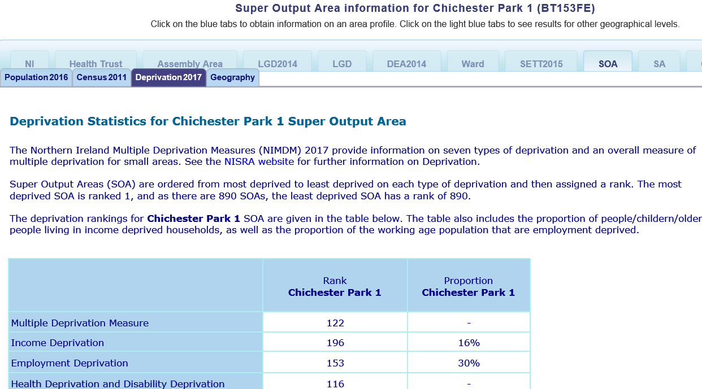

Step E: The information required for application is ‘Multiple Deprivation Measure’ which is circled in red.

Step F: Please insert the Multiple Deprivation Measure (MDM) into the table for each SOA.
2.3 | Specify the target group(s) you hope to work with and the issues you plan to address.
 | List the people who will make up your target group(s) (e.g. men, women, young people, mixed age and sex, older people, people at risk of homelessness, street drinkers) and the issues you plan to address (e.g. mental health, sexual health, isolation, housing, poverty)
2.4 | Provide a concise aim and summary of your proposed project?
 | Please make your aim and summary concise and focused as it will give the Assessment Panel a clear picture of what the project will entail. You should articulate clearly what you want to do and how you are going to do this. It should include things like the number of groups you hope to work with, the number of people in each group, the approach you will use and the role of partners. (Maximum 150 words).
2.5 | Tell us why there is a need for this project?
Provide information on why there is a need for this BCPP project in YOUR area. In each of the following, think about need in relation to health but also in relation to the wider determinants e.g. housing, community infrastructure, income & education and how these impact on the health of individuals and communities being targeted.
All relevant information to evidence the need for your project should be included, for example:
- Findings from reports about the key issues in your area or for your proposed group e.g. Government research and statistics, local council reports and information, local surveys, case studies and audits.
- Evaluation reports, workshop and focus group findings and anecdotal evidence from your proposed group which evidence a need for work in this area. If you have received BCPP funding before, please include information from your project impact report. Contact us if you need a copy of this report.
- Anecdotal evidence heard through conversations within your community about issues that you think could be addressed through BCPP.
If a particular approach is being used, e.g. music or gardening, please provide evidence as to why you think this approach will help this project.
Tell us why you want to work with the Pharmacist and other external organisations. This should demonstrate how you think that working together will address the identified needs. It will also enable the Pharmacist and community partner to utilise their knowledge of the needs of the participants and what gaps in services and support this project could fill.
When explaining the need, look beyond the presenting issue (disease, lifestyle or medication issue) and think more about the person, the target group and the situation in which they are living and how this is impacting on their health. These factors must be taken into consideration in your BCPP project as they will have an impact on how any community-pharmacy partnership is planned and delivered. (Maximum 500 words)
An example -
We are in a deprived area (provide statistics) with a high number of single mothers (statistics). We hold a weekly parent and toddler group and it has become clear through conversations with the women that they have a lot of health issues e.g. post-natal depression, poor sleep, understanding children’s medication, weight. However, when we spoke to them more it is clear that they are faced with other factors e.g. damp housing, having no access to transport, not having a family or social network to support them and living on a low income. We hope to get Citizens Advice in talk about how to manage money and by working with them and the pharmacist we will be able to address the wider health needs of the group.
2.6 | How will the Pharmacy Partner contribute to the project?
 | It is important to detail how the Pharmacy Partner will be involved in the project from planning to evaluation. Be specific about their involvement and their unique contribution. Think about the number of sessions with groups and one to one support. Also, consider how sessions will be delivered and range of health issues the pharmacy may be able to contribute to. It is important that the pharmacist attends the sessions co-delivered by the external community/voluntary organisations as this is how they will learn more about other services in the community. (Maximum 250 words).
2.7 | How will the Community partner contribute to the project?
 | Tell us how the Community Partner will be involved in the project. If the community partner is the lead partner, detail how they will be involved in managing, providing co-ordination and evaluation. Be specific about what they will contribute and how they will engage using a community development approach. This also gives you the opportunity to tell us about the work your organisation currently carries out and how this may add to the value of your project. (Maximum 250 words)
2.8 | How will the group members (participants) contribute to the project? Think about their skills and local assets will be used.
Tell us about the role of the group participants in the project, how they will be involved the planning and design, for example, when and where sessions will take place, session format and the topics covered,
You will also need to demonstrate how you will identify and use the skills of your participants. Tell us how you will work together to use their lived experience (tacit knowledge) to enhance the programme.
If you have been funded before it is important to reflect on the last group you worked with and show how you got participants involved in co-designing the programme and sharing their experiences. (Maximum 250 words),
2.9 | Which external organisations do you hope will deliver sessions in your project and why? Level 2 projects must work with a minimum of four external community/voluntary organisations. Please articulate why you have proposed any ‘soft’ sessions/
Think about your target group(s) and their needs. This will help you determine the four-external community/voluntary organisations that you could work with for the sessions. What services do organisations provide that could benefit the project?
For example, mental health – Aware NI; suicide prevention – PIPS; benefits advice - Citizens Advice Bureau; older peoples’ issues – Age NI.
Often projects will also deliver some other sessions e.g. yoga, reflexology, cookery. We call these ‘soft’ sessions and recognise that they can be very helpful in engaging participants and can provide much needed skills and relaxation. These do not, however, count as the external community/voluntary sessions and you will need to articulate how they will contribute to meeting the needs you have identified in Q2.5.
(Max 250 words)
2.10 | What will you do to recruit participants and keep them engaged in the project?
Meaningful engagement is an important part of community development and essential to building relationships and developing trust which is critical to bring about sustainable changes in health. Good engagement practice will enable the group to explore the range of issues the impact on their health and to share and develop knowledge, skills, experience and expertise.
Tell us how you plan to recruit participants on to the programme and how you will keep them engaged.
It may be useful to re-read the information about BCPP and the meaning of an asset-based approach.
(Max 250 words)
2.11 | What difference do you hope this project will make? Think about the BCPP outcomes in your answer (see Guidance Notes p3)
Tell us what changes you hope will happen as a result of the project. It is important that you consider the BCPP outcomes and how your project will meet them. (You may want to use bullet points for this.)
You should also demonstrate how the approached used (partnership working and using a community development approach) will help you to achieve these changes.
Remember to reflect on your earlier answers as the difference made should correspond with your aim and summary and meet your identified need. (Maximum 500 words)
2.12 |  | Activity Plan
This activity plan allows you to detail what the project will involve. It shows the Assessment Panel that you have thought through exactly what you need to do, how you need to do it and enables you to deliver your project.
Level 2 projects work with one or two groups (occasionally we will allow three groups if the need is well articulated.) Each group will have a maximum of 15 participants and the participants must remain the same for the duration of the sessions. Include information on the duration of sessions and how often the sessions will take place e.g. Weekly or fortnightly.
To receive the full £12,000 grant, projects must deliver a minimum number of sessions with the pharmacist and a minimum number of sessions with external community/voluntary organisations. This is set out in the table below:
Number of groups in a project | Minimum number of sessions with pharmacist | Minimum number of sessions with external community/voluntary organisations
One group | 18 sessions with the group =  - 10 led sessions  - 8 co-delivered or attended sessions | Minimum 4
Two groups | 9 sessions in each group =  - 5 led sessions  - 4 co-delivered or attended sessions | Minimum 2 in each group

The pharmacist must attend the sessions led by external community/voluntary organisations. This is a fundamental part of BCPP as it enhances the pharmacist’s and participants knowledge of the services and support available in their local community.
The activity plan should be detailed with a realistic time frame against which you will set tasks and targets. Your response to this question will help you manage the project and help justify the costs being requested.
Your activity plan and budget have to match up. All BCPP projects have set pharmacy partner rates which are outlined in the next section. It is therefore essential that you include as much detail as possible in your activity plan to justify your costings. If costs are built in that do not correlate to the activity plan and overall application, it will be very difficult for the Assessment Panel to determine if the costs are valid.
You do not have to list what topics and issues will happen at each session, but it would be good to indicate what you think the project may cover. We know this may change depending on the interests of your group. Co-planning and co-delivery is important i.e. showing how and when external community/voluntary sector organisations will co-deliver sessions.
The justification for any sessions in your activity plan that are delivered by external organisations (including soft sessions) should be explained in Q2.9.
Time should be allocated within sessions for pharmacy one-to-one support. We will not fund sessions that are solely for this purpose. If this is a requirement you must state explicitly in your application why there is a need.
When writing your timescale, please note that Level 2 projects must be completed within one year of receiving the first BCPP grant payment. For example: an application made in February will receive their first payment in June of that year. Please refer to the Application and Funding timeline for further details.

Sessions / Activities | Who is involved?  Who is leading the session? | Number of attendees | Timescale

2.13 | Budget
This section provides details of the funding sought. The maximum grant is £12,000. The funding is to facilitate delivery of the projects and is not for capital equipment.
Make sure the costs are specific and should be guided by your previous answers i.e.
- Q2.4 Aim and summary
- Q2.5 Need
- Q2.6 & 2.7 Involvement of partners
- Q2.8 Group member contribution
- Q2.9 External organisation sessions
- Q2.12 Activity plan
This will help you justify your costs. Adding in costings that have not been detailed throughout the application form will be deemed to be inappropriate and will be disallowed.
Pharmacy Partner rates are paid at £200 per day and £100 per half day.

Sessions:
- For each pharmacy led session, BCPP allows a half-day for preparation and half-day for delivery, this equates to a total full day rate of £200.
- For a pharmacy co-delivered or attended session that requires no preparation BCPP allows the pharmacy partner a half-day rate of £100. This includes sessions that are led by an external community/voluntary organisation and ‘soft’ sessions such as complementary therapy, exercise etc.

Other pharmacy costs:
- BCPP allows the Pharmacy Partner two days for planning and evaluation meetings (2 x £200 or 4 x £100)
- Pharmacists are required to attend mandatory CDHN training on Community development, health literacy and health inequalities. BCPP allows a full-day rate of £200 for attendance at the training. The training will help fulfil their CPD obligations.

These costs allow the pharmacist to leave their premises and have a locum or second pharmacist in their place so that pharmacy work can continue.

Community Partner costs – neither management nor administration costs should exceed £25 per hour. We do not meet salary costs for posts in community and voluntary organisations where funding is already in place from another source. Please include planning, evaluation and attendance at mandatory CDHN training in your costs.

External organisations, including community and voluntary organisations and other groups and agencies (soft sessions) are paid at a max of £25 per hour. This cost is a maximum of three hours per session, for example, one-hour preparation and two hours delivery.

Overheads - office costs including printing, photocopying, phone, postage

Accommodation – room rental

Hospitality tea, coffee, refreshments, snacks

Monitoring and Evaluation Level 2 BCPP projects are required to complete a mid-way and a final monitoring report. Both the partners and group participants are required to complete BCPP evaluation questionnaires. We have a set rate of £1500 for monitoring and evaluation. This will be paid on completion of the project. Funding will be withheld from groups who are not compliant.

Other
- Travel: BCPP only fund participant and volunteer travel expenses. Staff or pharmacy travel is not permitted unless collection of participants is involved.
- Volunteer expenses: Subsistence is available to volunteers.
- Childcare: Please contact BCPP for advice at the application stage
- Other expenses: Please contact BCPP for advice at the application stage.

Here is an example of a completed budget. Please ensure the budget matches what you have set out in your activity plan.
Item | Details including number of hours, rate per hour/day and number of sessions etc | Cost
Pharmacy Partner | Lead on 10 sessions x £200 = £2000  Co-deliver /attend 8 sessions x £100 = £800  Planning and evaluation 4 meetings x £100.00 = £400  Attendance at mandatory training x £200 | £3400
Community Partner –  Management plus administration | Support development of the programme, management and coordination.  60 hrs x £25/hr = £1500  Admin 70 hrs x £10/hr = £700 | £2200
External community and voluntary organisations, groups and agencies | External comm/vol orgs 4 x 3 hours each @ £75 (1 hr prep, 2 hr delivery) = £300  Yoga sessions 6 x £25/ph = £150 | £450
Overheads (Office costs including printing, photocopying phone and postage | Telephone - £220  Photocopying - £235  Printing/stationary – £240  Insurance - £59 | £754
Accommodation | Room hire 24 sessions x £65 | £1560
Hospitality | Hospitality for 24 sessions x 18 people (£70 per session ) = £1680  Celebration lunch 18 people x £12 per head = £216 | £1896
Monitoring and Evaluation | Completion of BCPP mid-way and final monitoring reports, partner questionnaires and participant questionnaires. | £1500
Other e.g. childcare, volunteer, travel | Volunteer expenses: 24 sessions x £10 | £240
Total |  | £12,000.00

2.14 | CDHN provides specific guidelines and training in relation to evaluation. There is a mandatory requirement for both partners and the group participants to complete evaluation questionnaires. BCPP staff will provide training on this. Please mark ‘Yes’ to confirm your commitment to meeting BCPP evaluation requirements.
2.15 | CDHN provides specific guidelines and training in relation to managing finances. All BCPP projects must complete the monitoring report provided and follow the rules of reporting. Please mark ‘Yes’ confirm that you will use the BCPP financial procedures.
2.16 | CDHN provides mandatory training to both the community and pharmacy partner on community development, health literacy and health inequalities. Please mark ‘Yes’ confirm that you will attend the training, if funded.
2.17 | To avail of BCPP funding, the community and pharmacy partner must agree to CDHN Statement of Values (see P2) Please mark ‘Yes’ confirm that you will agree to the Statement of Values, if funded.
2.18 | To avail of BCPP funding, both partners must accept free membership of CDHN to receive the CDHN ezine with up to date information on funding, training and events. Please mark ‘Yes’ confirm that you accept membership, if funded.
2.19 | BCPP projects must adhere to BCPP publicity guidelines and take part in publicity for BCPP on request. More information on request. Please mark ‘Yes’ confirm that you will do this, if funded.
2.20 | If you have had your accounts audited by an external Auditor, please mark ‘Yes’. If you marked ‘Yes’, please send a copy of your audited accounts. If you marked ‘No’, please send a copy of your most recent bank statement to enable us to ensure your organisation is solvent and able to receive grant funds.
2.21 | Projects are encouraged that will pro-actively endorse and not exclude Section 75 groups. Section 75 requires public authorities carrying out functions that relate to Northern Ireland to have due regard for the need to promote equality of opportunity between:  - persons of different religious belief, political opinion, racial group, age, marital status or sexual orientation  - men and women generally  - persons with a disability and persons without and  - persons with dependants and persons without.  Please mark ‘Yes’ or ‘No’
2.22 | Your application should indicate clearly if the project intends to work with children or vulnerable adults at any stage. If you are, you need to ensure that you have the appropriate policies and procedures in place regarding working with children or vulnerable adults. Please note: you may be required to provide evidence of this policy / procedure. Please mark ‘Yes’ ‘No’ or ‘Not Applicable’.
2.23 | Your application should state clearly if it involves volunteers. If it does, you need to ensure that you have the appropriate policies and procedures in place regarding working with volunteers. Please note: you may be required to provide evidence of this policy / procedure. Please mark ‘Yes’ ‘No’ or ‘Not Applicable’.
2.24 | If you providing childcare directly related to this BCPP project you need to ensure that you have the appropriate policies and procedures in place to support the provision of childcare. Please note: you may be required to provide evidence of this policy / procedure. Please mark ‘Yes’ ‘No’ or ‘Not Applicable’.
2.25 | Your application should state clearly if it provides support services. If these services will be offered through BCPP, please ensure the services offered comply with the principles of good practice as laid out by the HSCB. Please note: you may be required to provide evidence of this policy / procedure. Please mark ‘Yes’ ‘No’ or ‘Not Applicable’
2.26 | This must be completed and signed by the pharmacist who will be working on the project. The participating pharmacist must work within the bounds of their profession when they are delivering the project.

Part 3: Applicant Declaration
This section must be completed before submitting the form. On signing, the applicant is declaring the information on the form is accurate, the organisation has the authorisation to accept the grant and to repay the grant in the event of grant conditions not being met. Where the applicant is a pharmacy employee, he/she should obtain the assurances of support and countersignatures required from the employing community pharmacy contractor.
All applications must be received by the closing date. CDHN must receive an email version, preferably with scanned signatures. If you are unable to include scanned signatures, we will accept an email version but this must be backed up by a posted copy with the signatures.

Information about successful applications

Successful applicants are required to take up the offer of the grant within two weeks of receiving the contract; otherwise the Community Development and Health Network reserve the right to withdraw their offer.

Building the Community-Pharmacy Partnership
Community Development and Health Network
30a Mill Street, Newry, BT34 1EY

Tel: 028 3026 4606
Fax: 028 3026 4626

bcpp@cdhn.org

Funded by:
