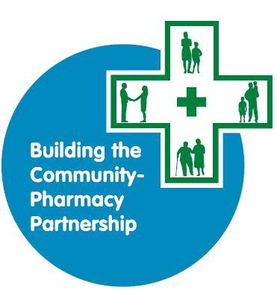

BCPP Level 1 Guidance Notes

TO ACCOMPANY THE BCPP LEVEL 1 APPLICATION FORM

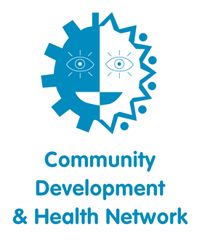

Applications must be submitted via email to: bcpp@cdhn.org

CONTENTS

1. Introduction to Community Development and Health Network (CDHN)
2. Building the Community-Pharmacy Partnership Programme (BCPP)
3. Assessment criteria
4. Question by question guide
5. Information about successful applications

|  |
| --- |
| * Keep to the word count for each answer. * Applications must be typed. * You must email your application form to [bcpp@cdhn.org](mailto:bcpp@cdhn.org) by the closing date. If you are unable to include signatures in your emailed application, you must also send a signed hard copy in the post. * On signing the application, you must have commitment from both partners to deliver the project. * Please keep a copy of submitted application for your records. |
|  |
|  |

# **Introduction to Community Development and Health Network (CDHN)**

**Our Vision** is for an end to health inequalities.

**Our Mission** is building a fairer and more equal society and improving people’s lives, health and wellbeing through community development which releases individual and community capacity and influences change.

**Our Statement of Values:**

* **Leading with Passion**

In all our work we will lead with passion using our expertise and belief in what we are doing to inspire others.

* **Tenacity and Flexibility**

We will be tenacious, focused and flexible to ensure an end to health inequalities.

* **Integrity and Respect**

Through our words and actions, we will work with integrity and respect.

* **Equality and Inclusivity**

We will recognise and promote equality and inclusivity to ensure we achieve social justice for all.

* **Valuing Others**

We will value individuals, teams, partners and communities recognising this as a key strength to achieving our vision.

To avail of BCPP funding, the community and pharmacy partner must agree to

* CDHN Statement of values and;
* accept free membership of CDHN to receive the CDHN ezine with up to date information on funding, training and events

# **Building the Community-Pharmacy Partnership (BCPP)**

The Building the Community-Pharmacy Partnership (BCPP) Programme is led by CDHN and funded by the Health and Social Care Board (HSCB), with strategic direction provided by a multi-agency Steering Group.

**BCPP Aim: To bring pharmacy and community together to reduce health inequalities using an asset-based community development approach**

|  |  |  |
| --- | --- | --- |
| **BCPP Strategic outcomes** | **BCPP Project outcomes** | |
| **1.    Project participants are enabled and supported to achieve their full health and wellbeing potential** | 1.1 | Participants' health literacy is improved |
| 1.2 | Participants have improved understanding of the social factors (e.g. money worries, housing, stress) that can influence health (social determinants) |
| 1.3 | Participants are more confident to self-manage their health and take action on factors which influence health |
| 1.4 | Participants have improved knowledge of services and support for health and social issues |
| 1.5 | Participants' health and wellbeing is improved |
| **2.    Pharmacy is enabled and supported to fulfil their role as advocates for public health within communities** | 2.1 | Pharmacists are more aware of health issues in the participants' community |
| 2.2 | Pharmacists have better understanding of the context and conditions of people’s lives and factors that influence health (social determinants) |
| 2.3 | Pharmacists have improved health literacy understanding and skills |
| 2.4 | Pharmacists have improved knowledge of services and support for health and social issues and are better able to signpost patients |
| 2.5 | Pharmacy services are better utilised |
| **3.    Community partners are enabled and supported to recognise and address health inequalities in their community** | 3.1 | Community partners are more aware of health issues in the participants’ community |
| 3.2 | Community partners have better understanding of the context and conditions of people’s lives and factors that influence health (social determinants) |
| 3.3 | Community partners have improved health literacy understanding and skills |
| 3.4 | Community partners have improved knowledge of services and support for health and social issues and are more able to signpost/refer people in their community |
| **4.    Social capital is increased to build connected and engaged communities** | 4.1 | Participants have an improved sense of connectedness and belonging |
| 4.2 | Participants develop new skills, knowledge and experience in their community |
| 4.3 | More equal relationships are developed between the participants, community partner and pharmacy |

**What is BCPP?**

BCPP supports communities and community pharmacists to work in partnership to address locally defined needs so that people make connections, listen to and understand each other better and work together to address the social determinants of health and health inequalities.

**What approach is used in BCPP projects?**

The programme uses an asset-based community development approach; bringing people and communities together to achieve positive change using their own knowledge, skills and lived experience around the issues they encounter in their lives. We recognise that health is impacted by a wide range of factors and the BCPP programme aims to address health inequalities by championing action across these social determinants. Co-production is key and the most successful projects are the ones where the power balance shifts and the pharmacist and community see each other’s strengths and assets. This breaks down the patient/professional barrier and gives the pharmacist an opportunity to learn about the group and hear their stories.

**Why pharmacy?**

The role that community pharmacies play in delivering primary care and in educating and engaging with local communities is continually developing in both the health care and community and voluntary sectors. They have a unique position, within their localities, of being the ‘open door’ to the Health Service. The policy direction for Community Pharmacy is clearly that it will play a greater role in contributing to better health and wellbeing in the community. We believe that the local pharmacy is an important community resource where advice and support can be accessed on health and general wellbeing, as well as being somewhere that people can be signposted to other services. The community pharmacy is increasingly recognised and used in this way. The pharmacist, their staff members and premises are easily accessible to all, including those who are most vulnerable and find it more difficult to navigate other areas of the health care system.

BCPP projects provide a fantastic opportunity to explore the potential of community pharmacy in this role; to begin to build relationships between pharmacy and community partners and to see how we can engage creatively with those most vulnerable to poor health (the poor, the elderly, those with young children and other marginalised groups such as those with disabilities, mental health problems and their carers). It also allows the opportunity to engage and learn from other community and voluntary sector organisations.

**What type of projects are funded by BCPP?**

BCPP projects are very diverse; they engage with many different communities e.g. women’s groups, people who are homeless, victims of violence etc in different areas (rural and urban) around different issues e.g. poverty, bereavement, social isolation, but the model of working does not change.

**Who do BCPP projects work with?**

In each project the community and pharmacy partner will engage with a small group of **12-15 individuals**. We find this size is perfect for group work as in a small group, participants feel safe to engage and discuss what are often very personal issues about themselves and their families. **Group work is core to the success of the programme.** When people meet and engage with others in similar circumstances as themselves, it reduces feelings of self-blame and hopelessness. They realise they are not alone or ‘bad’ and this gives them the support to make small changes and the opportunity to address bigger issues together. A key element of BCPP is that the community partner and the pharmacist understand the context and conditions of people’s lives. This enables them to improve their health literacy and offer support that is relevant and timely. The partners will learn from the participants about health issues in their community and together they will identify individual and local assets that can tackle these.

Building trust and developing relationships is a core part of every BCPP project. As the sessions take place in a community and with the community partner, the Pharmacist can build on existing relationships.

*BCPP Level 1 Application and Funding timeline*

The BCPP funding programme is ongoing, this means that applications can be made at any time and the application process is always open. There will be two closing dates for Level 1 each year, these will be advertised on the CDHN website.

After the closing date applications are assessed within 3 weeks of the closing date. The table below show the approximate timeline for an application with a closing date in May.

|  |
| --- |
| **BCPP Level 1 Application and approximate funding timeline** |

|  |  |  |  |  |  |
| --- | --- | --- | --- | --- | --- |
|  | **Closing date** | **Assessment** | **Notification**  **/Contracts** | **Funding distributed**  **80% 20%** | |
| **May Round** | May | June | July | July | December |

# **What is the difference between Level 1 and Level 2 BCPP projects?**

**Level 1 projects** are BCPP taster projects, they give partners the opportunity to get a flavour of a BCPP project without committing to a full project (**Level 2**).In Level 1 projects, partners are able to explore how they work together, the management of the project, organising the sessions, working with the group and the evaluation, monitoring and reporting requirements. It also allows the partners to work with people in their community to identify the need for a Level 2 project, the topics or issues they would like to explore further and whether there is an interest from people in the community to commit to a full BCPP project.

**What is the commitment for pharmacy to BCPP projects?**

* **Level 1:** There is a set pharmacist commitment for Level 1 projects that cannot be changed.
* **Level 2**: There is a pharmacist commitment guide for Level 2. We would like all projects to follow this guide, however, we recognise that this may not always be suitable. If a project wishes to deviate from this commitment, the reasons must be stipulated clearly in the BCPP application.

**Can organisations who have previously received Level 2 projects apply for Level 1 funding?**

Normally no, however, you will be eligible to apply again if you are working with

* a different partner for the first time, i.e. a new pharmacist or community partner
* a group with very different issues/needs to the previous Level 1.

In such instances you will need to demonstrate clearly, on the application why you feel there is a need for another Level 1 project.

**Can you apply for Level 2 funding without having a Level 1 project?**

Yes, some organisations have the knowledge, understanding and capacity to deliver a Level 2 without first delivering a Level 1.

**Do you still fund Level 3 projects?**

No, we no longer fund Level 3 projects.

**What are the key differences between a Level 1 and Level 2 Project?**

The key differences between Level 1 and Level 2 projects are summarised in the following table:

|  |  |  |
| --- | --- | --- |
|  | **Level 1: BCPP taster** | **Level 2: BCPP full project** |
| No of groups | 1 | 1 or 2 |
| No of participants in each group | 10 to 15 (max) | 10 to 15 (max) |
| Maximum grant | £2,500 | £12,000 |
| Project length | Max 6 months | Max 12 months |
| Reporting requirements | * One final report | * One mid-way report * One final report |
| Evaluation requirements | * Community partner questionnaire * Pharmacy partner questionnaire | * Community partner questionnaire * Pharmacy partner questionnaire * Participant START questionnaire * Participant END questionnaire |
| **Pharmacy commitment** | **Level 1: BCPP taster** (Setpharmacist commitment) | **Level 2: BCPP full project** (Pharmacist commitment guide/ suggested numbers) |
| Pharmacist led sessions | 5 | 10 |
| Pharmacist co-delivered/attended sessions | ½ day =   * One ½ day session with a community/voluntary organisation | 4 (8 x ½ day sessions) =   * 4 community/voluntary sector * 1 celebration dinner/event * 3 other |
| Pharmacist *mandatory* training | n/a | 1 day |
| Pharmacist planning and evaluation days | ½ day | 2 days |
| **Total pharmacy commitment** | **6 days** | **17 days** |

# **Assessment Criteria**

**Who can apply?**

BCPP funding is open to constituted community/voluntary organisations and community pharmacies based in Northern Ireland. Projects must be a partnership between a community/voluntary organisation and a community pharmacy. Either can be the lead applicant but both partners must be named in the application form.

A constituted community/voluntary organisation is a group run on a voluntary basis and is set up as an organisation with a management committee, constitution and its own bank account. A copy of the constitution will be required with the application.

The community pharmacy must hold a current contract with HSCB. Qualified pharmacists not associated/affiliated to a pharmacy holding a HSCB contract are not eligible to apply.

**Who is not eligible?**

* Private companies and statutory organisations.
* Third party applicants e.g. an organisation applying as lead partner to deliver the project in a different community organisation. The community organisation itself or the pharmacy must be the lead partner.

**What we fund?**

* Level 1 Funding is for a grant of up to £2,500 for a project that can last up to six months.
* A community/voluntary organisation and a community pharmacy to work in partnership to deliver a six-session project to the same core group of people.
* Of the six sessions, five led by the pharmacist and one co-facilitated by the pharmacist and an external community/voluntary organisation.

**What do we not fund?**

* Health fairs
* Projects that work with a different group of people every session
* Projects with more than 15 people in the core group
* Projects seeking to enhance sports performance or focus only on lifestyle issues
* Capital equipment

**What is the funding criteria?**

* A clear concise summary
* An identified community need
* Clear partnership working between the pharmacy and the partner community/voluntary organisation and another external community/voluntary organisation.
* A clear activity plan including who your group is made up of, how many people are in the group and how often you will meet i.e. weekly, fortnightly. You can give an idea of topics you hope to cover but you must engage with your group to decide topics if your funding is successful. The activity plan must address the community need.
* Realistic costings that relate to your overall application and activity.
* Overall value for money regarding what the project aims to achieve.

**Refusal of Grant**

Grants may be refused for the following:

* The proposed project does not meet with BCPP funding criteria.
* The application form is incomplete.
* An old BCPP application form has been submitted. Please ensure you have downloaded the correct application for the funding round.
* The application form is a copy of a previous form you submitted to CDHN
* The application does not meet the minimum scoring.
* Previous BCPP project outcomes and/or reporting requirements were not satisfactory.
* The lead partner has an open BCPP project.
* The application has not adhered to the word count.
* Sometimes demands on BCPP grants outstrip the funds available and this means that some good applications, while meeting the criteria may not be successful. In this case, funding will be awarded first to those with the highest overall score.

### **Question by Question Guide**

**PART 1: Partner information**

**1.1a; b and c** Provide details of the **community partner** (community/voluntary organisation) and **pharmacy partner** applying. Tell us who will lead the project – either the community or pharmacy partner. The lead partner will be the main contact person who can give more information on the application. If successful, the contract will be with the lead partner and they will be responsible for managing the budget and returning all financial documentation, monitoring information and evaluation forms to CDHN.

**1.2a** This question is to ensure the community/voluntary organisation or community pharmacy applying can receive a grant, otherwise, the application will not pass the basic criteria assessment.

If you are a group, you must be constituted so please attach a copy of your constitution with your application.

**1.2b** If you are a pharmacy, you must have the approval of the Pharmacy Contract Holder.

**1.3** If you are a community/voluntary organisation, please provide the Assessment Panel with a brief history of your organisation and of the work you are currently carrying out. This information will give the Panel an insight into the work of your organisation and how this may contribute to and complement the work of your BCPP project. (Maximum 100 words)

**1.4a & b Previous applicants**

Please state Yes or No to let us know whether the lead partner has previously received a BCPP grant. If the lead partner has previously received BCPP funding, tell us how many times they have been funded at each Level.

An organisation, as a lead partner, can receive Level 1 funding on a maximum of two projects.

Example:

Level 1

1

Level 2

0

Level 3

0

**1.5** Please state how many paid staff (if any) there are in the partner organisation.

**PART 2: Assessment**

**2.1 Project details**

1. Tell us which Health and Social Care Trust area/s your project will cover.
2. Tell us which Council area/s your project will cover.
3. Is it Urban/Rural or across both areas?

2.2 We need the Super Output Area (SOA) as we record the areas we are working in and we map this to the Multiple Deprivation Measure (MDM) index. You need to provide the SOAs that your **participants live in** **or come from**, not just where your premises are based.

Visit: [www.nisra.gov.uk/ninis](http://www.nisra.gov.uk/ninis)

**Step 1:** Select ‘Area Profile’ on the tabs along the top

**Step 2**: In ‘Search for area’: Enter the postcode(s) of the area(s) the core group will be from and Under ‘Geography’, select SOA. Click on the arrow highlighted to continue to the next step.

**Step 3:** From the results click on your ‘Geography Result’.

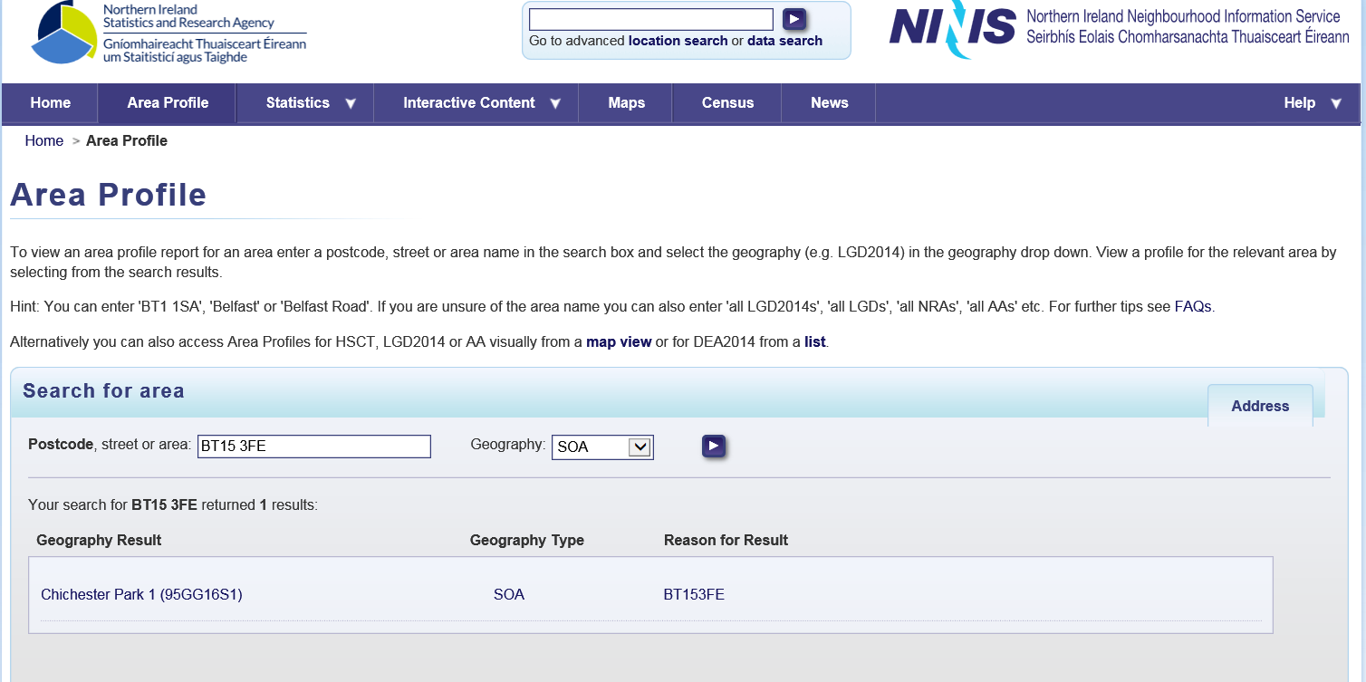

**Step 4:** The next screen opens with the ‘Population 2016’ tab as default. Please select the ‘Deprivation 2017’ tab for the MDM information required for application.

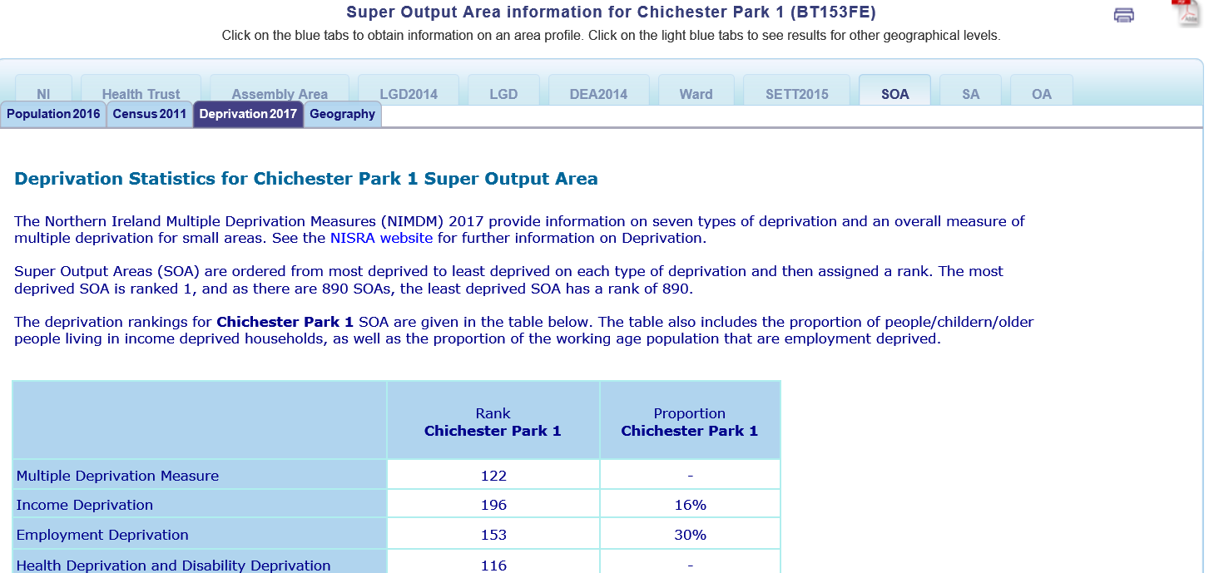

**Step 5:** The information required for application is ‘Multiple Deprivation Measure’ which is circled in red.

**Step 6:** Please insert the Multiple Deprivation Measure (MDM) into the table for each SOA. This helps us determine the areas that you will be targeting. We understand that your project may cover a wide geographical area and, in this case, please provide us with a maximum of 3 SOAs.

**2.3 Specify the target group you hope to work with and the issues you plan to address.**

List the people who will make up your **target group** (e.g. men, women, young people, mixed age and sex, older people, people at risk of homelessness, street drinkers) and the **issues** you plan to address (e.g. mental health, sexual health, isolation, housing, poverty)

**2.4 Provide a concise summary of your proposed project?**

Please make your summary concise and focused as it will allow the Assessment Panel to get a clear picture of what the project will entail. You should articulate clearly what you want to do and how you are going to do this. It can include things like the number of people you hope to engage with, the approach you will use and the role of partners. (Maximum 150 words)

**2.5 Tell us why there is a need for this project?**

Provide information on why there is a need for this BCPP project in YOUR area. In each of the following think about need in relation to health but also in relation to the wider determinants e.g. housing, community infrastructure, income & education and how this impacts on the health of individuals and communities being targeted.

All relevant information to evidence the need for your project should be included, for example:

* Findings from reports about the key issues in your area or for your proposed core group e.g. Government research and statistics, local council reports and information, local surveys, case studies and audits.
* Evaluation reports, workshop and focus group findings and anecdotal evidence from your proposed core group which evidence a need for work in this area. If you have received BCPP funding before, please include information from your project impact report. Contact us if you need a copy of this report.
* Anecdotal evidence heard through your conversations within your community about issues that you think could be addressed through BCPP.

If a particular approach is being used, e.g. music or gardening, provide evidence as to why you think this approach will help this project.

Tell us why you want to work with the Pharmacist and other partners. This should demonstrate how you think that working together will address the identified needs. It will also enable the Pharmacist and other partners to utilise their knowledge of the needs of the participants and what gaps in services and support this project could fill.

When explaining the need, look beyond the presenting issue (disease, lifestyle or medication issue) and think more about the person, the target group and the situation in which they are living and how this is impacting on their health. These factors must be taken into consideration in your BCPP project as they will have an impact on how any community-pharmacy partnership is planned and delivered.

*An example*

*We are in a deprived area (provide statistics) with a high number of single mothers (statistics). We hold a weekly parent and toddler group and it has become clear through conversations with the women that they have a lot of health issues e.g. post-natal depression, poor sleep, understanding children’s medication, weight. However, when we spoke to them more it is clear that they are faced with other factors e.g. damp housing, having no access to transport, not having a family or social network to support them and living on a low income. We hope to get Citizens Advice in talk about how to manage money and by working with them and the pharmacist we will be able to address the wider health needs of the group.*

**2.6 How will the Pharmacy partner contribute to the project?**

It is important to detail how the pharmacy partner will be involved in the project from planning to evaluation. Be specific about their involvement and their unique contribution. Think about the type and amount of work the pharmacist will take part in e.g. number of sessions with groups, one to one support, referral etc. Also, consider the type of input and range of health issues the pharmacy may be able to contribute to. (Maximum 100 words)

**2.7 How will the community partner contribute to the project?**

Tell us how the community partner will be involved in the project. If the community partner is the lead partner, detail how they will be involved in managing, providing co-ordination and evaluation. Be specific about what they will contribute and how they will engage using a community development approach. This also gives you the opportunity to tell us about the work your organisation currently carries out and how this may add to the value of your project. (Maximum 100 words)

**2.8**  **Which external community and voluntary organisation do you hope to work with for one session and why?**

Think about your target group and their needs. This will help you determine the external community/voluntary organisation that you could work with for one session. What services do organisations provide that could benefit the project?

For example, mental health – AWARE NI; suicide prevention – PIPS; benefits advice - Citizens Advice Bureau; older peoples’ issues – Age NI. (Maximum 100 words)

**2.9 Activity Plan**

This activity plan allows you to detail what the project will involve. It shows the Assessment Panel that you have thought through exactly what you need to do, how you need to do it and enables you to deliver your project. The activity plan should be detailed and set in a realistic time frame against which you will set tasks and targets. Your response to this question will help you manage the project and help justify the costs being requested. **It is therefore essential that you include as much detail as possible in your activity plan to justify your costings. If costs are built in that do not correlate to the activity plan and overall application, it will be very difficult for the Assessment Panel to determine if the costs are valid.**

You do not have to list what topics and issues will happen at each session, but it would be good to indicate what you think the project may cover. We know this may change depending on the issues your core group want covered. Co-planning and co-delivery is important i.e. showing how and when the pharmacist will work with other providers and facilitators. Your project should be made up of the same core group of people (Max 15).

Please provide a **timeline** for your project. Projects must be completed within six months from the date that 80% of the funding is distributed. Please refer to the Application and Funding timeline for details. (Maximum 150 words)

**2.10**  **Budget**

This section provides details of the funding sought. **The maximum grant is £2,500.** The funding is to facilitate delivery of the projects and is not for capital equipment.

|  |
| --- |
| **Make sure the costs are specific and should be guided by the summary (Q7) and need (Q8), involvement of partners (Q9-11) and your activity plan (Q12).**  These will help you justify your costs. **Adding in costings that have not been detailed throughout the application form will be deemed to be inappropriate and will be disallowed.** |
|  |

* **Pharmacy Partner** rates are paid at £200 per day
* For each pharmacy led session, BCPP allows a half-day for preparation and half-day for delivery, this equates to a total full day rate of £200.
* For a pharmacy co-facilitated session that requires no preparation and is led by an external community/voluntary organisation, BCPP allows the pharmacy partner a half-day rate of £100.
* In level 1 projects BCPP also allows the pharmacy partner a half-day (£100) for planning.
* These costs allow the pharmacist to leave their premises and ensure the core work in the pharmacy can continue by them being able to put a locum or second pharmacist in their place.
* Please note, Pharmacy Partner costs are set in a level 1 application and are already included in the budget.
* **Community Partner** costs - neither management nor administration costs should exceed £25.00 per hour. We do not meet salary costs for posts in community and voluntary organisations where funding is already in place from another source.
* **External community partners** are paid at a max of £25.00 per hr.
* **Overheads -** office costs including printing, photocopying, phone, postage.
* **Accommodation** - room hire
* **Hospitality** - tea, coffee, refreshments, snacks
* **Monitoring and evaluation** - Level 1 BCPP projects are required to complete a final monitoring report and the partners and core group participants are required to complete BCPP evaluation questionnaires. The completion of these documents is allowed in your costs. They should not exceed 10% of the overall grant.
* **Other**
* *Travel:* BCPP only pay for participant and volunteer travel. Staff or pharmacy travel is not permitted
* *Volunteer expenses:* Must be explained in the application.
* *Childcare:* Please contact BCPP for advice at the application stage
* *Other expenses:* Please contact BCPP for advice at the application

stage

**Here is an example of a completed budget:**

|  |  |  |
| --- | --- | --- |
| **Item** | **Details including number of hours, rate per hour/day and number of sessions etc** | **Cost** |
| Pharmacy Partner | * ½ day planning session (1/2 day x £100) * Lead on 5 sessions (planning & delivery) x £200/day * 1 sessions attend activity/co-facilitate session (1/2 day x £100) | 1200.00 |
| Community Partner –  Management plus administration | Support development of programme, management, organising sessions, partner input, participation recruitment and follow up. (Maximum £25 per hour) | 400.00 |
| External Community/Voluntary organisation | * Input from other providers e.g. Aware, PIPs etc alongside the pharmacist for 1 session * £25/hr x 2 hours | 50.00 |
| Overheads   * Office costs - including printing; photocopying; phone; postage | * Telephone - £50 * Photocopying - £50 * Printing - £60 | 160.00 |
| Accommodation | 6 sessions @ £25 | 150.00 |
| Hospitality | 17 people x 6 sessions | 290.00 |
| Monitoring and Evaluation | Completion of BCPP final monitoring report, partner questionnaires and core group questionnaires | 250.00 |
| Other e.g. childcare, volunteer, travel |  | 0 |
| **Total** |  | 2500.00 |

|  |  |
| --- | --- |
| 2.11 | CDHN provides specific guidelines and training in relation to evaluation. **There is a mandatory requirement for both partners and the group participants to complete evaluation questionnaires.** BCPP staff will provide training on this. Please mark ‘Yes’ to confirm your commitment to meeting BCPP evaluation requirements. |
| 2.12 | CDHN provides specific guidelines and training in relation to managing finances. All BCPP projects must complete the monitoring report provided and follow the rules of reporting. Please mark ‘Yes’ confirm that you will use the BCPP financial procedures. |
| 2.13 | CDHN provides mandatory training to both the community and pharmacy partner on community development, health literacy and health inequalities. Please mark ‘Yes’ confirm that you will attend the training, if funded. |
| 2.14 | To avail of BCPP funding, the community and pharmacy partner must agree to CDHN Statement of Values (see P2) Please mark ‘Yes’ confirm that you will agree to the Statement of Values, if funded. |
| 2.15 | To avail of BCPP funding, both partners must accept free membership of CDHN to receive the CDHN ezine with up to date information on funding, training and events. Please mark ‘Yes’ confirm that you accept membership, if funded. |
| 2.16 | BCPP projects must adhere to BCPP publicity guidelines and take part in publicity for BCPP on request. More information on request. Please mark ‘Yes’ confirm that you will do this, if funded. |
| 2.17 | If you have had your accounts audited by an external Auditor, please mark ‘Yes’. If you marked ‘Yes’, please send a copy of your audited accounts. If you marked ‘No’, please send a copy of your most recent bank statement to enable us to ensure your organisation is solvent and able to receive grant funds. |
| 2.18 | Projects are encouraged that will pro-actively endorse and not exclude Section 75 groups. Section 75 requires public authorities carrying out functions that relate to Northern Ireland to have due regard for the need to promote equality of opportunity between:   * + persons of different religious belief, political opinion, racial group, age, marital status or sexual orientation;   + men and women generally ;   + persons with a disability and persons without; and   + persons with dependants and persons without.   Please mark ‘Yes’ or ‘No’ |
| 2.19 | Your application should indicate clearly if the project intends to work with children or vulnerable adults at any stage. If you are, you need to ensure that you have the appropriate policies and procedures in place regarding working with children or vulnerable adults. *Please note: you may be required to provide evidence of this policy / procedure.* Please mark ‘Yes’ ‘No’ or ‘Not Applicable’. |
| 2.20 | Your application should state clearly if it involves volunteers. If it does, you need to ensure that you have the appropriate policies and procedures in place regarding working with volunteers. *Please note: you may be required to provide evidence of this policy / procedure.* Please mark ‘Yes’ ‘No’ or ‘Not Applicable’. |
| 2.21 | If you are providing childcare directly related to this BCPP project, you need to ensure that you have the appropriate policies and procedures in place to support the provision of childcare. *Please note: you may be required to provide evidence of this policy/procedure.* Please mark ‘Yes’ ‘No’ or ‘Not Applicable’. |
| 2.22 | Your application should state clearly if it provides support services. If these services will be offered through BCPP, please ensure the services offered comply with the principles of good practice as laid out by the HSCB. *Please note: you may be required to provide evidence of this policy/procedure.* Please mark ‘Yes’ ‘No’ or ‘Not Applicable’ |
| 2.23 | This **must be** completed and signed by the pharmacist who will be working on the project. The participating pharmacist must work within the bounds of their profession when they are delivering the project. |

|  |
| --- |
| **Part 3: Applicant Declaration** |
| This section must be completed before submitting the form. On signing, the applicant is declaring the information on the form is accurate, the organisation has the authorisation to accept the grant and to repay the grant in the event of grant conditions not being met. Where the applicant is a pharmacy employee, he/she should obtain the assurances of support and countersignatures required from the employing community pharmacy contractor.  **All applications must be received by the closing date. CDHN must receive an email version, preferably with scanned signatures. If you are unable to include scanned signatures, we will accept an email version, but this must be backed up by a posted copy with the signatures.** |

# **Information about successful applications**

Successful applicants are required to take up the offer of the grant within **two weeks** of receiving the contract; otherwise the Community Development and Health Network reserve the right to withdraw its offer.

Building the Community-Pharmacy Partnership

Community Development and Health Network

30a Mill Street, Newry, BT34 1EY

Tel: 028 3026 4606

Fax: 028 3026 4626

[bcpp@cdhn.org](mailto:info@cdhn.org)

Funded by:

