IPH office space available to rent at Forestview, Belfast

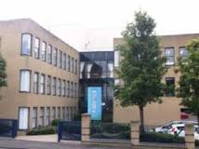
- 1st floor suite of approximately 2,137 sq ft (198.53 sq m). Consisting of 4 offices, a large open plan office (alternatively could be used as a seminar room) and a sizable meeting room or large office. Finished to a high specification and partially furnished.
- Dedicated on-site car parking (4 spaces available).
- Set in an excellent suburban office location (2 miles south of Belfast city centre adjacent to the junction of the Saintfield Road and the A55 Outer Ring).
- Easy access to the city centre and motorway network with good public transport links.
If you would like further details please contact Sharon Brennan by email: Sharon.Brennan@publichealth.ie or Telephone: 028 90 64 84 94

