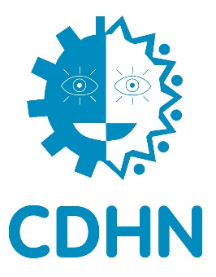
CDHN Voluntary Management Board – Monitoring Form

PRIVATE AND CONFIDENTIAL

Equal Opportunity Monitoring Form

To ensure the effective implementation of the Equal Opportunities Policy all applicants are requested to complete the following questionnaire. This questionnaire will be removed from your application form and will not form any part of the selection process.

This questionnaire will not be seen by either the short listing or interview panels.

Personal Details

Date of birth: ________________________________

Gender: Male Female

Marital status: Married Single Divorced Separated
Other________________________________________________ (please specify)

Please state your nationality or citizenship (for example, British, Irish, Polish):

_______________________________________________________________________________________

Ethnic origins

White Indian Pakistani

Bangladeshi Chinese Black African

Black-Caribbean Irish Traveller

Black-other ______________________________ (please specify)

Other _______________________________ (please specify)

A person has a disability if he or she has "a physical or mental impairment which has a substantial and long-term adverse effect on his or her ability to carry out normal day-to-day activities” (Disability Discrimination Act 1995).

Do you in accordance with the above have a disability? Yes No

If yes, please state nature of disability: ________________________________________

If no, have you ever had a disability? Yes No

Have you any caring responsibility? Yes No

Children Relative(s) Other None

Religious affiliation and/or community background
CDHN is required by The Fair Employment and Treatment (NI) Order 1998 to monitor the perceived religious affiliation and/or community background of its employees and applicants. In accordance with the Monitoring Regulations 1999, we are asking you to indicate the community to which you belong by ticking the appropriate box below:

I am a member of the Protestant community

I am a member of the Roman Catholic community

I am a member of neither the Protestant nor the Roman Catholic community

Please email this form to marionohare@cdhn.org

