CDHN Management Board Expression of Interest Form

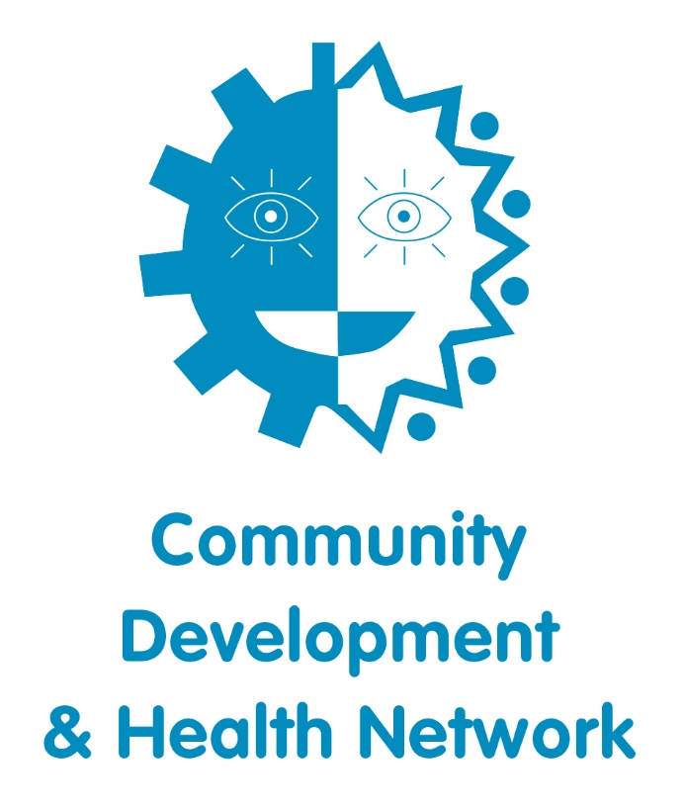

Voluntary Management Board Opportunity

Thank you for your interest in applying to join the Community Development and Health Network’s Management Board. Please use this form to provide useful information about yourself and to provide a good overview of why you are interested in this position. All information provided will be treated with the strictest of confidence.

Name:
Address:

Email:
Telephone:
Your current role and organisation, if applicable:
Current affiliations or membership of any organisations or professional bodies:

We are currently recruiting up to 5 new Board members.
Please indicate which role you are interested in. You may choose more than one.
Volunteer Board Member

Why do you want to join the Community Development and Health Network (CDHN) Board? (Max 300 words)

Tell us about your relevant knowledge and experience of the community development sector. Please share some examples in Community Development, Strategic Development, Health and Social Policy and Communications.

Please list the expertise, skills and experience that you would bring to the Board.

Please list any other positions you hold on other Boards, Committees or Organisations.

Time Commitment:
I am available to attend Board meetings 4-5 times per year, for 2 Hours, and can participate in strategic planning meetings with the staff team, 1-2 days per annum.

Conflict of Interest:
I am not aware of any reason why I should not be considered for the position of CDHN Board member.

I confirm that I do not have any conflict of interest that would preclude me from participating on the Board.

Your signature: _________________________________ Date:______________________

Please share the names and addresses of two character references (not relatives).
Referees must have known you for at least two years.

Referee 1 | Referee 2
Name:  Address:  Telephone: | Name:  Address:  Telephone:

Please return your completed Expression of Interest Form to:

Marion O’Hare, Community Development and Health Network marionohare@cdhn.org

By Tuesday 8th October before 5pm.

