CDHN Management Board Application Form

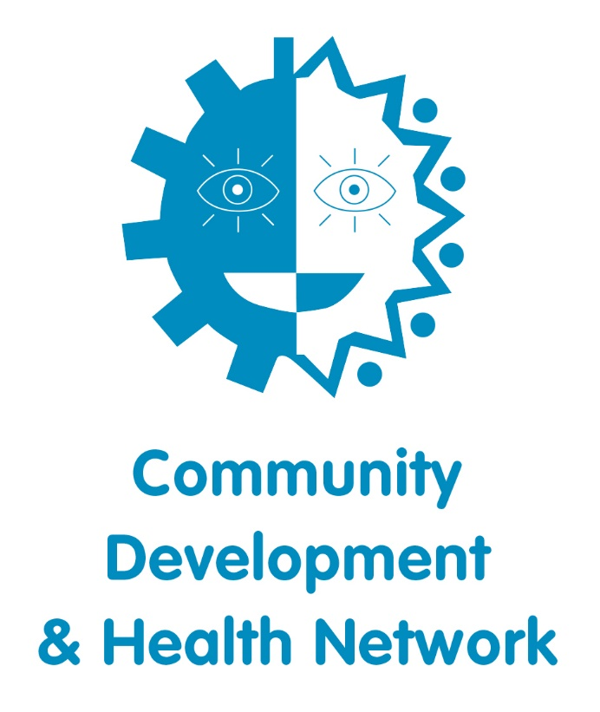

Voluntary Management Board Opportunity

Thank you for your interest in applying to join the Community Development and Health Network’s Management Board. Please use this form to provide useful information about yourself and to provide a good overview of why you are interested in this position. All information provided will be treated with the strictest of confidence.

Name:
Address:

Email:
Telephone:
Current affiliations | Name of Organisation and your Role

We are currently recruiting up to 5 new Board members.
Please indicate which role you are interested in. You may choose more than one.
Treasurer
Board Member

How familiar are you with the work of the Community Development and Health Network (CDHN)?

Why are you interested in joining the CDHN Board?

Your relevant knowledge and experience of the community development and health sector – please share some examples from your work or volunteering history.

What leadership skills & experience do you have that may be relevant to your role as a CDHN Board member?
If you are interested in the role of Treasurer, please share examples of your experience in finance.

Which of your skills would you most like to use on the Board? Please write below:
What types of experiences, development skills or interests would you like to gain from your participation on the Board?

Time Commitment:
I am available to attend Board meetings 4-5 times per year, for 2 Hours, and can participate in an all operation planning meeting with the staff team, 1-2 days per annum.

Conflict of Interest:
I am not aware of any reason why I should not be considered for the position of CDHN Board member.

I confirm that I do not have any conflict of interest that would preclude me from participating on the Board.

Your signature: _________________________________ Date:______________________

Please share the names and addresses of two character references (not relatives).
Referees must have known you for at least two years.

Referee 1 | Referee 2
Name:  Address:  Telephone: | Name:  Address:  Telephone:

If you are not selected as a Board member, or if you decide not to join, would you consider a volunteer position in an area that matches your skills and interests?

- Yes | - No | - Perhaps

Please return your completed Application and the Equal Opportunities Monitoring Form to:

Marion O-Hare, Community Development and Health Network marionohare@cdhn.org

By Tuesday 4th May 2021 before 12 noon.

