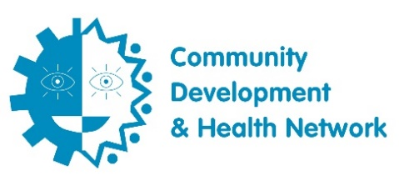

About Community Development and Health Network (CDHN)
The Community Development & Health Network (CDHN) advocates using community development approaches to empower local communities, improve health and wellbeing and end health inequalities. Our network works to achieve a fair and equitable society where all can enjoy the best possible health.
We train, engage, and support our 2,100 members to raise awareness of the root causes of poor health, health inequalities and the social determinants of health. We create opportunities for individuals, communities, and organisations to connect and share experiences from each other and learn. We support them to find their voice and use their expertise and lived experience to inform decision-making to tackle health, social and economic inequality.
Our Values
CDHN is committed to living the following values in all aspects of its work:
- Social justice
We believe in a society based on fairness, where everyone is considered equal and our health and wellbeing is not determined by where we are born, live or work. We are committed to creating the conditions where people can have more control of their own health and wellbeing and have a voice in decisions that affect them.
- Diversity
We are committed to celebrating diversity across the organisation and in the communities we serve.
- Integrity
We believe in being open, honest, and accountable in all our interactions and building relationships based on trust and mutual respect.
- Collaboration
We believe that working in partnership with members and other organisations is the best way of ending health inequalities.

